**QR Based License Detector**

**By**

**Saadia Mumraiz CIIT/FA19-MCS-019/ATK**

**Mariyam Arif CIIT/FA19-MCS-023/ATK**

**Supervisor**

**Mr. Najam Dar**



**COMSATS University Islamabad**

**Attock Campus - Pakistan**

**Master of Computer Science**

**2019-2021**

** COMSATS University Islamabad, Pakistan**

**Based License Detector**

**A project presented to**

**COMSATS University Islamabad, Attock Campus**

**In partial fulfilment**

**Of the requirement for the degree of**

***Master of Computer Science (2019-2021)***

**By**

**Saadia Mumraiz CIIT/FA19-MCS-019/ATK**

**Mariyam Arif CIIT/FA19-MCS-023/ATK**

**COMSATS University Islamabad**

**Attock Campus- Pakistan**

|  |  |  |  |
| --- | --- | --- | --- |
| **PROJECT ID** |  | **NUMBER OF MEMBERS** | 2 |

|  |  |
| --- | --- |
| **TTITLE** |  |

|  |  |
| --- | --- |
| **SUPERVISOR NAME** |  |

|  |  |  |
| --- | --- | --- |
| **MEMBER NAME** | **REGISTRATION NO** | **E-MAIL** |
|  |  |  |
|  |  |  |
|  |  |  |
|  |  |  |

**MEMBERS’ SIGNATURES**

**_________________________**

**_________________________**

**________________________­­­­­­­­­­­­­­­­_**

**­­­­­­­­­­­­­­­­­­____________**

________________

**SUPERVISOR’ NAME**

**FINAL APPROVAL**

Certified that we have read this project report submitted by Mr/Ms(Student/Students Name) and it is, in our judgment, of sufficient standard to warrant its acceptance by the Department of Computer Science, COMSATS University Islamabad, for the (MSc degree) in Computer Science.

***Committee:***

|  |  |  |
| --- | --- | --- |
| 1. External Examiner | | ___________________________ |
|  | | (Examiner Name) |
|  |  | Designation |
|  |  | University Name |
|  |  |  |
| 2. | Supervisor | ____________________________ |
|  |  | (Supervisor Name) |
| 3. | Chairperson | ____________________________ |
|  |  | (Chairperson Name) |
| 4. | Dean/Director | ____________________________ |
|  |  | (Dean/Director Name) |

**DECLARATION**

We hereby declare that the work submitted for the **module QR Based License Detector** is my original work. This work is done under the guidance of **Mr. Najam Dar** and this project work is submitted in the partial fulfilled of the requirements for the award of the degree of **master’s in computer science.** We have not copied from any other students’ work or from any other sources except where due reference or acknowledgment is made explicitly, nor has any part been authored by another person.

Saadia Mumraiz Mariyam Arif

___________ ___________

**CERTIFICATE OF APPROVAL**

It is to certify that the final year project of MCS “QR Based Licence detector” was developed by Saadia Mumraiz (CIIT/FA19-MCS-019) and Mariyam Arif (CIIT/FA19-MCS-023) under the supervision of “Mr. Najam Dar” and in his opinion, it is fully adequate in scope and quality for the degree of Master of Computer Science.

________________

---------------------------------------

**Supervisor**

Mr. Najam Dar

**Assistant Professor**

**CUI, Attock Campus**

---------------------------------------

**ACKNOWLEDGEMENT**

Firstly, we would like to thank our supervisor, Professor Mr Najam Dar, for his enthusiasm, patience, insightful comments, helpful information, practical advice and unceasing ideas that have always helped me tremendously in my research and writing of this project.

In the name of Allah, the most caring and most compassionate. I would like to thank relatives and friends who kept backing me up in all the times, both financially and morally. I would also like to thank technical helpers for his advice and promising me to work hard and smart. I have found him very obliging while discussing the amendment issues in this essay work. His censorious comments on my work have made me think of new ideas and techniques in the fields of amendment and software simulation.

I am thankful to the Allah Almighty who provides all the assets of every kind to us, so that we make their proper use for the advantage of mankind. May he keep provided us with all the assets, and the advice to keep helping the humanity.

**PROJECT BRIEF**

PROJECT NAME QR Based License Detector App

ORGANIZATION NAME Nil

OBJECTIVE To automate Traffic Police Department tasks

UNDERTAKEN BY Mariyam Arif

Saadia Mumraiz

SUPERVISED BY Mr. Najam Dar

Lecturer

Department of Computer science

|  |  |
| --- | --- |
|  | COMSATS UNIVERSITY ISLAMABAD |
| STARTED ON | 15- SEPT |
| COMPLETED ON | CONTINUE |
| COMPUTER USED | DELL |
| SOURCE LANGUAGE | JAVA ,Python |
| OPERATING SYSTEM  TOOLS USED | WINDOWS  Android Studio, Pycharm, Jupiter, Star UML |

**ABSTRACT**

As population increases, the number of vehicles is also increasing. Crimes involves traffic violation are also increasing in our country. Traffic Police has to check vehicles and drivers manually and it is a very difficult and time consuming task. To solve this problem, we propose an automated android based system “**License Detection using QR Code”**. Using this application, the traffic police can verify Vehicles as well as Driver’s license by scanning the QR code and matching information with driver’s DB.

On the other hand, vehicles verification task is also automated. Traffic Police Officer can scan Monogram of the vehicles and With Monogram accurately detected, the manufacturer recognition will become straightforward. Therefore, automatic logo detection is an important enabler in Traffic Securities. Our system will provide vehicle’s manufacturer information.

In this way, the verification for Traffic Police will be easily done and handled at the same platform without using any extra machines.

**Table of Contents**

Contents

1. Introduction 12

1.1 Objectives 13

1.2Problem Statement 13

1.3 Proposed solution 13

1.4 Scope of the system 14

1.5 Hardware Requirements 14

1.6 Software Requirements 14

1.7.1 Android Studio 15

1.7.2 PY Charm 15

1.7.3 Firebase 15

1.7.4 Python 15

2.1 Literature Review 17

2.2 Existing System 17

2.2.1 Driver license: scanner, reader, get info 17

2.2.2 Driving License Varification 18

2.2.3 Driving License Verification Pakistan 18

3.1. Requirement 22

3.2. Functional requirements: 22

3.2.1. Sign Up: 22

3.2.2. Sign In: 23

3.2.3. Information Reusability: 24

3.2.4. Edit/Record: 24

3.3. Non-Functional Requirements: 25

3.3.1 Performance: 25

3.3.2 Reliability: 25

3.3.3 Accuracy and consistency 26

3.3.4 Availability: 26

3.3.5 User Friendly: 27

3.3.6 Security: 27

3.3.7 Portability: 28

4.1 System Design 30

4.2 Methodology 30

4.2.1 Use Case Diagram: 31

4.3 Activity Diagrams: 32

4.4 Sequence Diagram: 34

4.5 Admin Activity Diagram: 35

5. Implementation……………………………………………………………………………………………………………………….38

5.1. Tools and Technologies……………………………………………………………………………………………………….39

5.2. Screenshots of Applications…………………………………………………………………………………………………39

6. Test and Evaluation…………………………………………………………………………………………………………………….45

6.1. Testing…………………………………………………………………………………………………………………………………….46

6.2. Basic Foundation of Testing………………………………………………………………………………………………..46

6.3. Types of Testing……………………………………………………………………………………………………………………….46

6.4. Test Case Results………………………………………………………………………………………………………………………48

7. Conclusion………………………………………………………………………………………………………………………………….50

7.1. Conclusion……………………………………………………………………………………………………………………………….51

7.2. Future Work……………………………………………………………………………………………………………………………..51

References……………………………………………………………………………………………………………………………………..52

**List of Figures**

|  |  |  |
| --- | --- | --- |
| **Figure No** | **Figure Title** | **Page number** |
| 4.2.1 | System Use Case | 15 |
| 4.3.1 | Traffic Officer Activity Diagram | 16 |
| 4.3.2 | License Office Activity Diagram | 17 |
| 4.3.3 | Driver’s Activity Diagram | 18 |
| 4.4.1 | License office Sequence diagram | 19 |
| 4.4.2 | TRP Officer Sequence diagram | 20 |
| 4.4.3 | Driver Sequence diagram | 21 |
| 4.5.1 | Data flow diagram | 22 |
| 5.1 | homepage Screen | 28 |
| 5.2 | Login for traffic police officer | 29 |
| 5.3 | License officer dashboard(Driver police registry) | 29 |
| 5.4 | Police registry | 30 |
| 5.5 | Driver registry | 30 |
| 5.6 | Police officer dashboard | 31 |
| 5.7 | Scan QR | 31 |
| 5.8 | Adding driver | 32 |
| 5.9 | Results of Scanning QR | 32 |
| 5.10 | Scanning monogram | 33 |

CHAPTER 1

INTRODUCTION

# 

# 1. Introduction

Pakistan is one of the countries having dangerous roads of world. The country is also lacking in modern traffic management training institutions. Due to increase in population number of vehicles is also increasing rapidly also the number of drivers is increasing. A valid driving License is essential for every person who wants to drive any kind of vehicle. People often make fake driving license, and it may cause of road accidents.

Detection of license, checking the validity of license is very difficult and time taking task in this crowded world. It is also a difficult task for the drivers to carry all the documents along with them, Sometimes they forgot to carry some documents and therefore they must pay fine.

Vehicles detection is also an important part of Traffic Police’s tasks. We all know this for a fact that original vehicle’s Monograms are way too expensive and getting them locally is near to impossible and chances are getting fake monograms. Logo recognition works on avoiding human mistakes in the environment where high security is needed. We are providing the feature of detecting Vehicle’s Logo in our App to avoid human mistakes in Traffic Police department of Pakistan.

Pattern Recognition is part of digital image technique and artificial intelligence. Logo or Monogram recognition is a process of understanding and defining the logos automatically by the automated systems. This task is done by training the system for many Monogram images.

QR codes are two-dimensional barcodes which has the ability to encode various type of information codes have gained popularity in different fields of application. On the other hand, our proposed system will use both of these emerging techniques to automate the Traffic Police work.

In this way, our application will facilitate traffic police employees to scan QR code and Monogram without using any kind of extra device to check the complete details of the driver’s license that is stored in the database like Driver’s Name, CNIC, Region, Expiry date etc. Also they can create Challan on the driver if he/she does any violation of traffic rules. Driver then can pay Challan online using their credentials.

## 1.1 Objectives

* Our goal of this project for traffic police is to find out authorized users and detect those having fake license*.* We Also wanted to give relief to the drivers, that they do not need to carry their document all the time.
* The key purpose of developing this application is to prevent magnetic card readers for detection.
* Our Objective behind this effort is to get rid of extra devices for scanning and verifying license. All these tasks could be done by this application.

## 1.2 Problem Statement

Pakistan is a highly populated country and the Traffic Police employees find difficulty in checking each driver's license when there is a lot of traffic. The main problem is how to make license identification process fast for both Traffic Police Officer and the driver, and how to make this manual system into automated. And there is not efficient way of detecting fake license users. Also there is no available android system that provides vehicle’s verification with Logo detection.

## 1.3 Proposed solution

We are proposing a system that will automate Traffic police manual work within just few seconds. Traffic Police Officer will be able to verify driver’s License and vehicle by just few clicks from their smart phone. He will open the app and scan QR code for license detection and the system will automatically match that information from database and send a message if the driver exists or not in the record. He also can detect original or fake vehicles Monogram by taking image of vehicle’s monogram or just by uploading image from Gallery and the system will automatically predict its company. Further it is also providing online Challan payment facility to the drivers and traffic police officer on the spot.

This system will also facilitate the drivers as they don’t have any need of keeping their license every time they only need to have a clear image of the license in their mobile phone. On the other hand if they have shortage of cash on the spot they can simply pay their Challan bills by their credit card online.

## 1.4 Scope of the system

It is very difficult for the drivers to carry all the physical documents along with them also it is time consuming task for the traffic police to check all the vehicles and driver’s license and their validity. There is too much of traffic on the roads of Pakistan, so the crimes involves un-registered vehicles are increasing day by day, in this respect Vehicle identification plays an important role in traffic and public security management. The scope and motivation of this application is that traffic police can verify the license in an easiest way by scanning QR code, It will show the record of drivers if it will match with driver’s database and for vehicle’s detection scan monogram to check whether the vehicle is of registered company or fake it will help to avoid car-related crimes. Also, the fake license and vehicles will be detected easily. It saves a lot of time and is secured. Drivers will be also facilitated as they do not need to carry all the documents along with them. They can also pay Challan bills online.

## 1.5 Hardware Requirements

The “QR Based License Detector” is android based mobile application which helps users like Driver, Traffic Police and admin to create a link with each other and detect the License and the vehicle’s verification easily. The traffic police Officer will just scan QR code and all the record will be matched from the database. The traffic police will be able to identify vehicles by Monogram detection feature. This application will be available at mobile application stores or similar services, so that user can download it without any cost

User must have an android device with active data connection.

## 1.6 Software Requirements

Android version of the device must be 7 or above this.

## 1.7 Tools

### **1.7.1 Android Studio**

Android studio is the official integrated development environment (IDE) for developing applications for Google’s Android Operating System. It is the much powerful tool for developing Android application than any other because of its amazing built in features that help the developer in developing Android applications efficiently. In this project Java is used for implementing logic and XML serves in designing user interface and other visual components.

### **1.7.2 PY Charm**

PyCharm is an integrated development environment (IDE) used in computer programming, specifically for the Python language. PyCharm is also compatible with Windows, Linux, and macOS. At the same time, the tools and features provided by PyCharm help programmers to write a variety of software applications in Python quickly and efficiently. The developers can even customize the PyCharm UI according to their specific needs and preferences.

### **1.7.3 Firebase**

The Firebase real time database is a cloud-hosted database. Data is stored as JSON and synchronized in real time to every connected client. This Database lets the developer to develop responsive, rich, collaborative applications and allow secure access from client-side code to the database directly.

### **1.7.4 Python**

Python is a famous object-oriented and high-level programming language. Python is capable of working on various platforms such as Windows, Mac, Linux, Raspberry Pi, and others. Another major advantage of using Python for Android app development is that it uses dynamic typing instead of static typing.

**CHAPTER 2**

**LITERATURE REVIEW**

# 2.1 Literature Review

We performed a systematic review on the system applications that are used for detecting driver’s license. Pakistan is a densely populated country where we face heavy traffic on roads so, verification of every vehicle and drivers manually is a difficult task for TRP (traffic police) officers.

We found some apps from the play store that claims to check license validation. But we could not found any application that is providing ease to traffic police department as well as drivers. So we felt need of a quick and latest system that perform verification tasks more efficiently using AI features like image processing and deep learning.

`

## 2.2 Existing System

### **2.2.1 Driver license: scanner, reader, get info**

This app allows the user to scan barcodes and QR Codes of the driver’s license and show information accordingly. But it is not connected with any regional DLIMS database to check license validity. We can say that it is simply used as a scanner application not for detection.

**Features:-**

* Runtime Scan
* Auto focus
* Scan from the gallery
* Show info

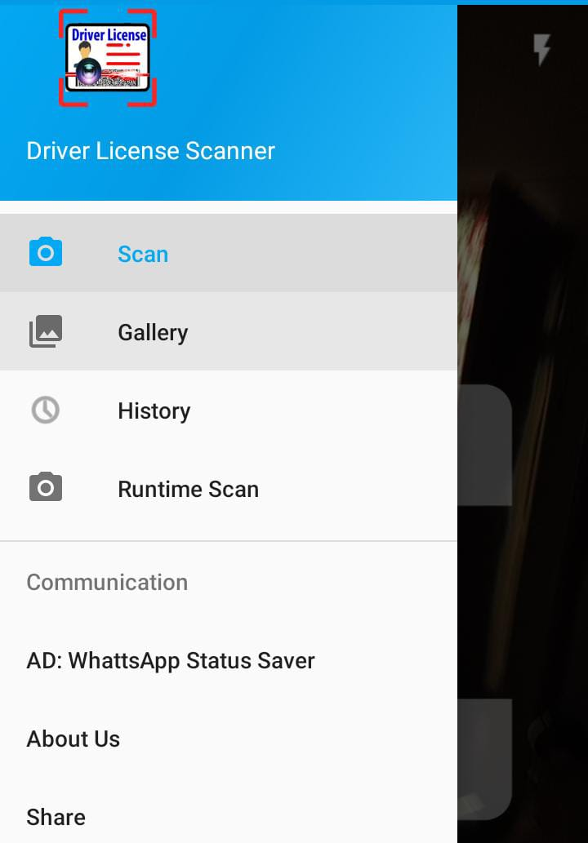

### **2.2.2 Driving License Verification**

This App was developed by Pakistan Online that check license validity on the basis of NIC number. When the user enters NIC number it will show information of his/her license and verify if it is valid or not.

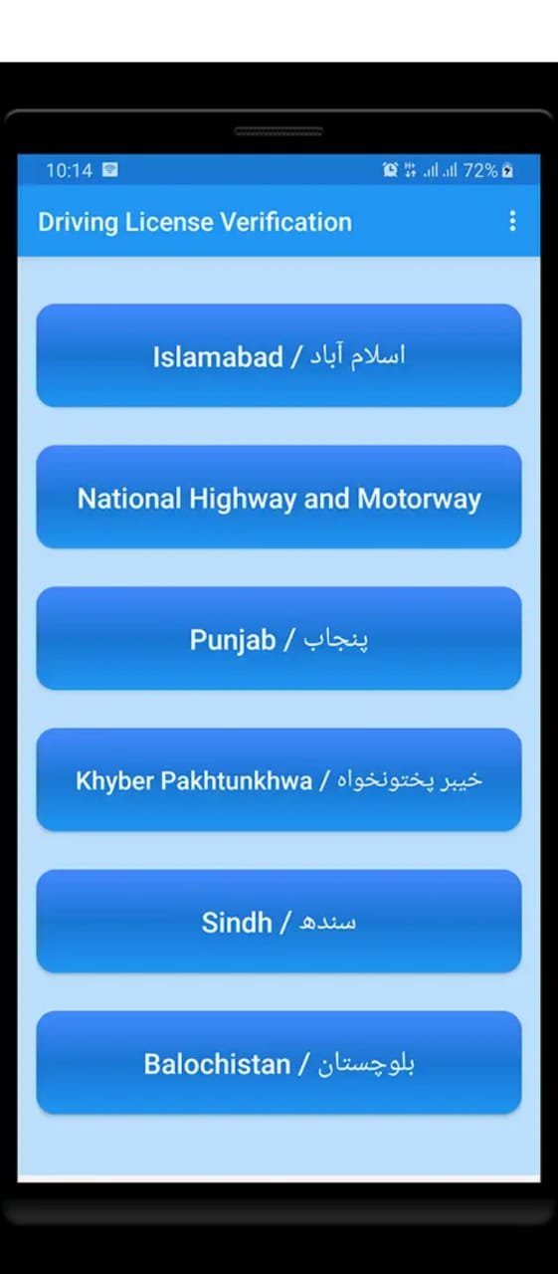 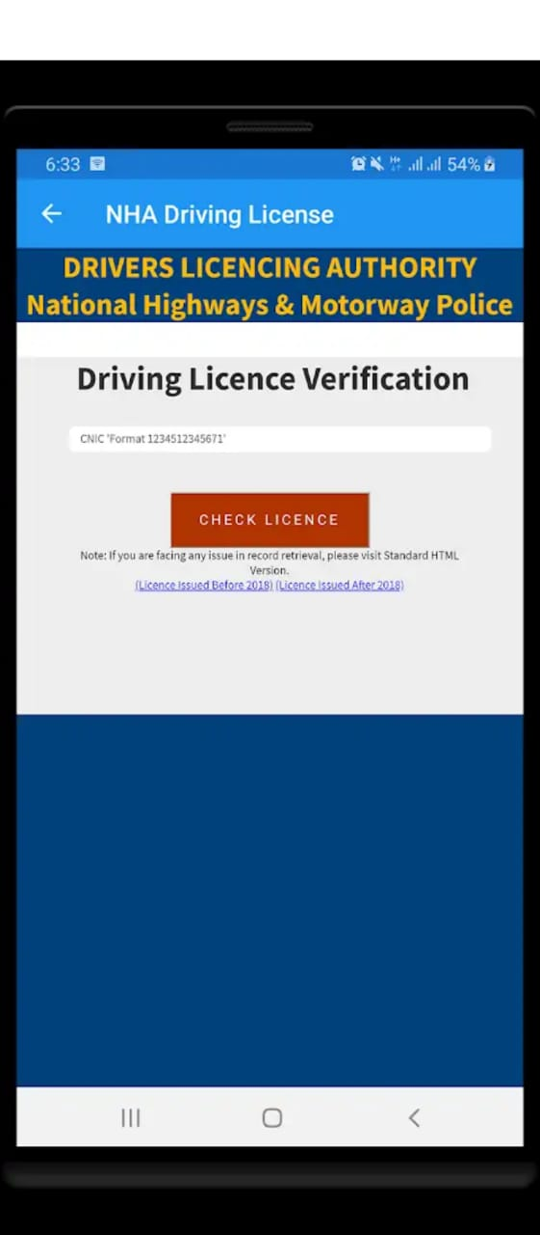

### **2.2.3 Driving License Verification Pakistan**

Driving License Verification Pakistan App is used to verify your driving license. App provides license verification by CNIC.

1. Either your License is valid or not

2. Check License number

3. License Registrations date

4. Driving License Expiry date

5. License Type

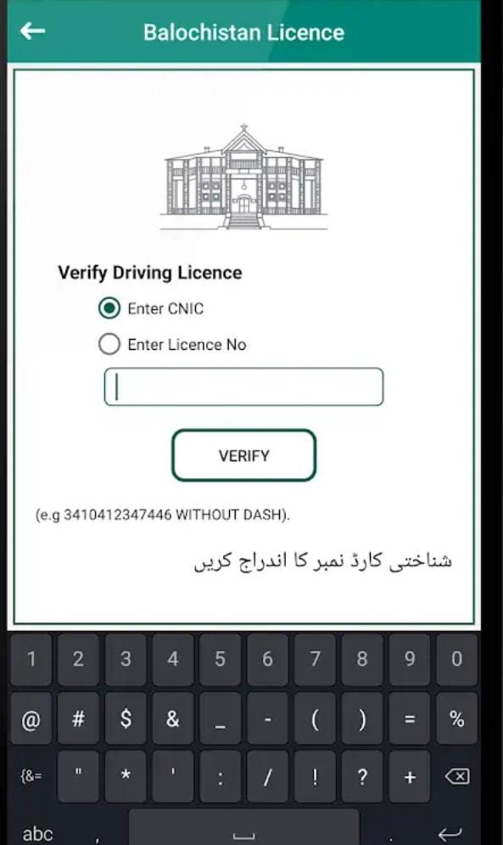

**Applications And Comparison Table**

|  |  |  |  |  |
| --- | --- | --- | --- | --- |
| **Functionality** | **QR based License Detection (Proposed)** | **Driving License Verification Pakistan** | **Scanner-Driver’s license scanner** | **DMV Driver License**  **Scanner & Decoder, Reader** |
| **Scan QR Code** | ✔ | ✖ | ✔ | ✔ |
| **Scan vehicle’s Monogram** | ✔ | ✖ | ✖ | ✖ |
| **Match info with driver’s database** | ✔ | ✔ | ✖ | ✖ |
| **Detect Fake license** | ✔ | ✔ | ✖ | ✖ |
| **Add/remove employees and drivers in the DB** | ✔ | ✔ | ✖ | ✖ |

## 2.3 Proposed System

After deep observation on the existing systems we come up with a unique idea of automating the process of traffic police by AI features. We use Image Processing and deep learning techniques in this project by scanning QR code for drivers and Monogram detection to verify vehicles. This will help out Traffic Police Officers to do their task in just few seconds without need of any extra detecting machines. All they need is just a smart phone with installed application. Our system will provide an ease to the drivers also, as they do not need to carry out their license everywhere they can simply keep a picture of their license on their smart phone to show the Traffic Police Officer anytime for verification purpose. On the other hand crimes related to cars are also increasing, so to solve this issue our system will detect registered vehicles with deep learning techniques.

**The System consists of three main modules:**

* **License Office**
* **Traffic Police Officer**
* **Driver**

The Traffic Police Officer will Login by his/her authorized email and password that is predefined added by License office and then he will take license details from drivers and Scan QR code and to check the validation of driver’s license system will automatically match the information with database and send a message when the valid or fake license detected.

For Vehicle’s detection the Traffic Police Officer will scan Monogram from the vehicle and the system will detect the company of the vehicle on the basis of its CNN trained system for verification.

Driver can enter to the system by entering his/her License number and then give his phone number to receive a confirmation code then he/she will be able to view and pay Challan using credit card number.

CHAPTER 3

REQUIREMENT SPECIFICATIONS

# 

# 3.1. Requirement

Requirements are defined as the features, functions, or tasks that must be completed to successfully wrap up a project. Requirements provide a crystal-clear picture of the work that needs to be done so you can plan your project appropriately to ensure the goals are met and your stakeholders are happy with the final output of your project. A requirements document defines what is needed from the product. It states the product's purpose and what it must achieve. It does not define how to deliver or build what is needed.

## 3.2. Functional requirements:

### **3.2.1. Sign Up:**

|  |  |
| --- | --- |
| **Name:** | **FR-1: Sign Up** |
| **Description:** | For using this application, any user must log in or sign up for the application to register him/her. |
| **Rationale:** | No user will use this application without logging in or signing up. This is the important part of the system for users to log in or signing up. |
| **Fit Criterion:** | The following data is mandatory for the framework for Signing Up.   * The user would type their proper name and password. The device would then allow access to the app after verification or validity. * When the user types the wrong name or password, or both, the device would not allow the user access to the application. |
| **Dependencies**: | If the user does not log in or sign up with this application, the user would unable to use the other functions. |

**Table-1**

### **3.2.2. Sign In:**

## 

|  |  |
| --- | --- |
| **Name:** | **FR-2: Sign In** |
| **Description**: | If the user wants this application, he/she must need to sign in or log in to app by entering their valid email and Password. |
| **Rationale:** | The system will perform the authentication technique to ensure whether the entered Name and Password are valid or not for the pre-existing users in the system. After authentication and ensuring the entered Name and Password are correct, the system will grant access to pre-existing users to the system whether he/she is Farm Owner or the User. If the authentication is invalid i.e., the user enters wrong Name and Password, then the system will not grant access to the app.. |
| **Fit Criterion:** | For Signing In, the user must enter the following details to the system.   1. **Email**   There should be a valid email id of the user to access this application so that he/she can use this application.   1. **Password:**   The data type that will be used for the Password is also String. The user can enter different password consisting of alphabets, numbers, or any special characters. The password should have no more than 25 characters. |
| **Dependencies**: | If the user does not sign on to the system, the user will not be able to enter the system to get the proper services. |

**Table-2**

### **3.2.3. Information Reusability:**

|  |  |
| --- | --- |
| **Name:** | **FR-3: Information Reusability** |
| **Description:** | This previously stored information of the user can be re-used for future order requests for the ease of users. |
| **Rationale:** | If the user wants to add his new expense record it is possible to store it with the previous record, so it is so helpful for the user to keep his all records. |
| **Fit Criterion**: | The user will be able to use his previously stored record for his new records he can also modify the details. |
| **Dependencies**: | This functionality depends on database management system as the information will be stored in the database. |

**Table-3**

### **3.2.4. Edit/Record:**

|  |  |
| --- | --- |
| **Name:** | **FR-4: Edit Record** |
| **Description:** | The users can edit their personal information as well as they can edit the order details. |
| **Rationale:** | If the user wants to change his information like his expense they can also edit or modify that. |
| **Fit Criterion:** | The users will be able to edit their information regarding their expenses |
| **Dependencies:** | This functionality depends on database management system as the information will be stored in the database. |

**Table-4**

## 3.3. Non-Functional Requirements:

### **3.3.1 Performance:**

|  |  |
| --- | --- |
| **Name:** | **NF-1: Performance** |
| **Description:** | It must be very easy to store and retrieve data. The performance is calculated in the time of response. |
| **Rationale:** | The user will stop using the app, if data is not stored and recovered easily, time is wasted. |
| **Requirement**  : | If the Internet is available, then the storing and calculating records would be measured in 2s to 3s. |

**Table-5**

### **3.3.2 Reliability:**

|  |  |
| --- | --- |
| **Name:** | **NF-2: Reliability** |
| **Description:** | The system should be reliable that the load of data in the database should not crash the system. |
| **Rationale:** | If the system is not effective, the system's complexity will be enhanced and the whole record will be put at risk. Because of any load in its database, the application should not crash. |
| **Requirement**  : | The system must have best modern tools. |

**Table-6**

### 3.3.3 Accuracy and consistency:

|  |  |
| --- | --- |
| **Name:** | **NF-3: Accuracy** |
| **Description:** | All data contained in the database must be reliable, i.e., all information must be right, and the information should be clear. |
| **Rationale:** | If the stored data is not reliable, so the device would have inaccurate and unreliable user accounts. As a result, the success will be lost to the app. The Tailor stores would not be able to accommodate the records of customers.   * If the customer wants to use his previously saved record the system should provide the same record efficiently. * The bill on the order basis should be accurate without any errors * Orders history should be in a sequence of orders. |
| **Requirement:** | The system should have specialized tool for storing accurate information. |

**Table-7**

### **3.3.4 Availability:**

|  |  |
| --- | --- |
| **Name:** | **NF-4: Availability** |
| **Description**: | Ensure that this app is accessible at any time. The application should be accessible with an active Internet connection 24/7 a day, |
| **Rationale**: | If the device is not working all time, the need for any user cannot be fulfilled. As a result of this the application would stop being used by many users. |
| **Requirement**: | Due to having an external database, i.e., Sql lite, the system should be online. |

**Table-8**

### **3.3.5 User Friendly:**

|  |  |
| --- | --- |
| **Name:** | **NF-5: User Friendly** |
| **Description:** | This application should be user-friendly, i.e., it should be easy to use for any application-related user and users should not experience any trouble using the app. |
| **Rationale:** | If the application is not user-friendly, it cannot be used by anybody. When using the app, it would build problems for the users and the app will be of no benefit for certain users.   * The user should easily use it * The user should be able to understand the flow of the system |
| **Requirement**: | The system should only support the English language and meaningful words. It should use certain terms and phrases that are convenient for any user connected with this app to understand. |

**Table-9**

### **3.3.6 Security:**

|  |  |
| --- | --- |
| **Name:** | **NF-6: Security** |
| **Description**: | This app should be secure for users, i.e. only valid and authorized users with proper authentication should use the app.  • Only signed up users should be able to use the system due to security issues |
| **Rationale**: | If the system is not safe, its security will be endangered. Therefore, the unauthorized users will have access to the data   * To secure the system i.e. only valid user can view and change data, this constraint is included. * Non-register user cannot access the data |
| **Requirement**: | The user must state their right email and password, before accessing the app |

**Table-10**

### 

### **3.3.7 Portability:**

|  |  |
| --- | --- |
| **Name:** | **NF-7: Portability** |
| **Description**: | Make user this app should be portable to every user’s device. It should run on all the Android devices. |
| **Rationale**: | If the application is not portable, so certain users of different Android devices may decline to use the software or stop using it. |
| **Requirement**: | The system should be designed in a way it should run on all the Android base devices. |

**Table-11**

**CHAPTER 4**

**SYSTEM DESIGN**

# 

# 4.1 System Design

As we know A System is a set of interacting entities and attributes, so in this chapter we will describe the system design and analysis that is being built. The system specifications, problem areas, use cases data flow diagrams, sequence diagram and activity diagrams are explained in this chapter. The purpose of the system design is to define a comprehensive solution based on different models and diagrams.

## 4.2 Methodology

Methodology can be described as a strategy that tells that how this system is working and completed. A methodology involves the study of methods in a particular domain. A method is a framework describes the activities involved in defining, building and implementing a system.

We are using Incremental Methodology for our system. Purpose of choosing this methodology is that we are developing in increments so if changes are required, we can change according to our needs.

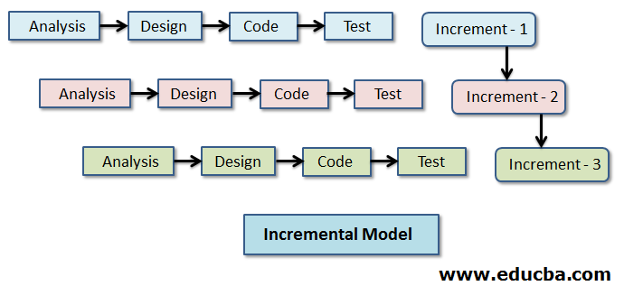

* Easy identified errors of the system and removed early, and the system will progress without any errors.
* During this practice, any suggestion by our supervisor on the working of the system we can easily change and implement.
* Test after every increment will ensure the working of the system as if it is working efficiently or not.
* It is flexible and less expensive to change requirements and scope.

### **4.2.1 Use Case Diagram:**

A Use Case diagram is a behavioural diagram that models the functionality of a system using actors and Use Cases. Use Cases represents high level functionalities and how a user will interact and handle the system.

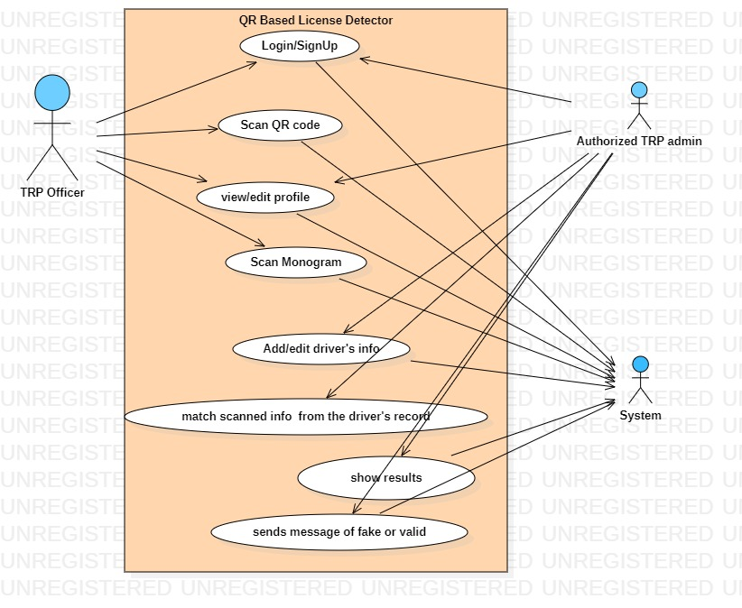

**Diagram 4.2.1 Use case**

### **Description:**

In the above use case diagram TRP Officer, admin and system are represented as an actor. TRP Officer and TRP admin complete their login credentials and enters the system and do their respective task as mentioned.

## 4.3 Activity Diagrams:

Once the system use cases have been identified, activity diagrams can be used to illustrate the steps involved in achieving a use case goal, showing the activities and the order in which they take place. An activity diagram portrays the control flow from the starting point to the end representing various decision paths that exists in an execution.

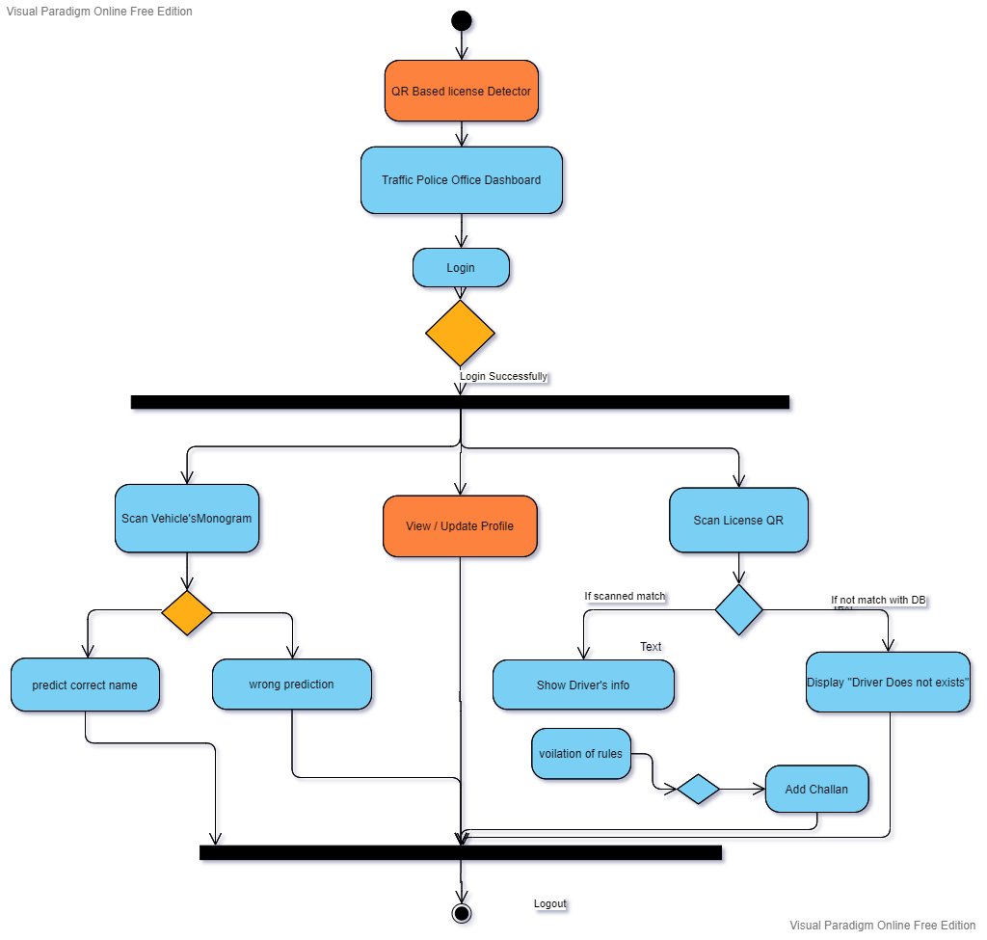

**Diagram 4.3.1 TRP officer activity diagram**

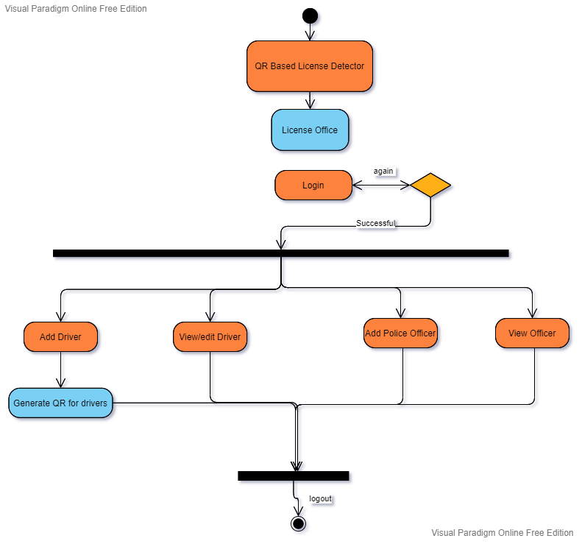

**Diagram 4.3.2 License Office activity**

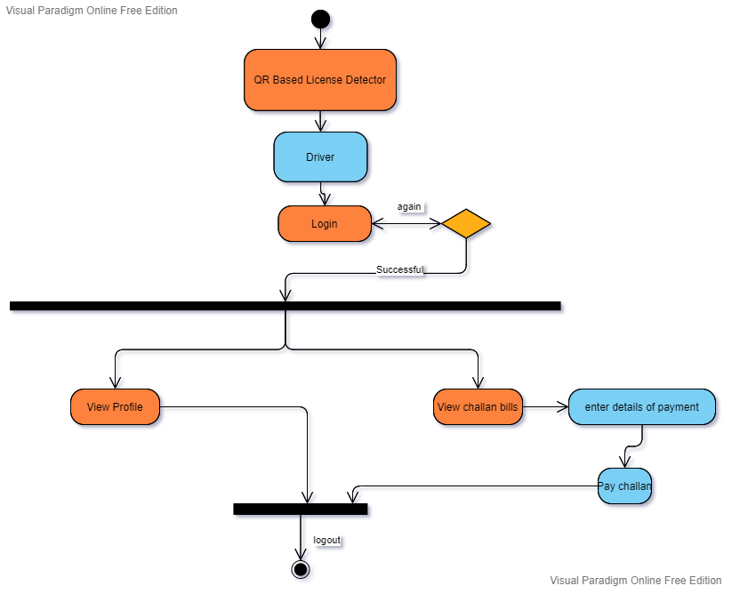

**Diagram 4.3.3 Driver**

## 4.4 Sequence Diagram:

Sequence diagrams describe interactions among classes in terms of an exchange of messages over time. A sequence diagram is a good way to visualize and validate various runtime scenarios. These can help to predict how a system will behave and to discover responsibilities a class may need to have in the process of modelling a new system.

## 4.5 License Office Sequence Diagram:

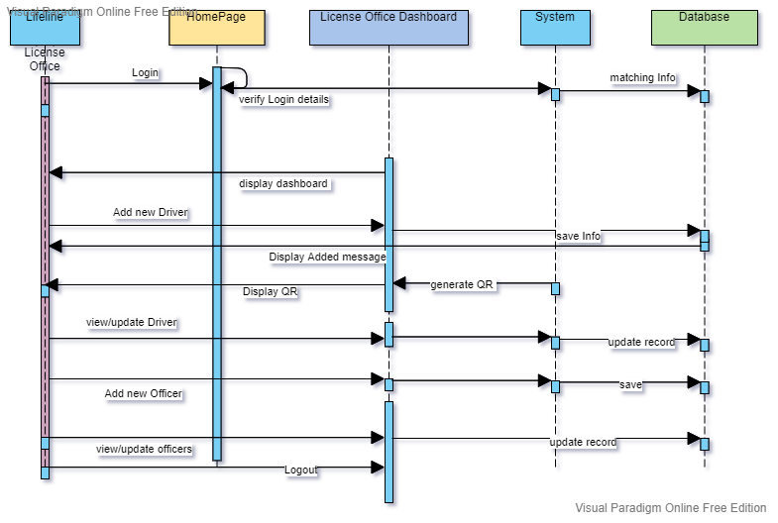

Diagram 4.4.1 Sequence diagram for License Officer

## 4.6 TRP Officer Sequence Diagram

## C:\Users\Track Computers\Downloads\Book a Seat.png

**Diagram 4.4.2 sequence diagram for TRP Officer**

## 4.7 Driver’s Sequence Diagram

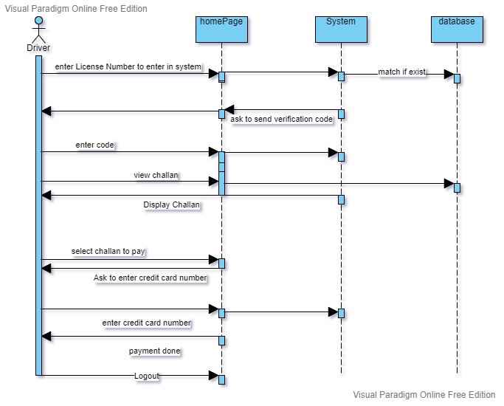

**Diagram 4.4.3 driver sequence diagram**

## 4.5 Data Flow Diagram

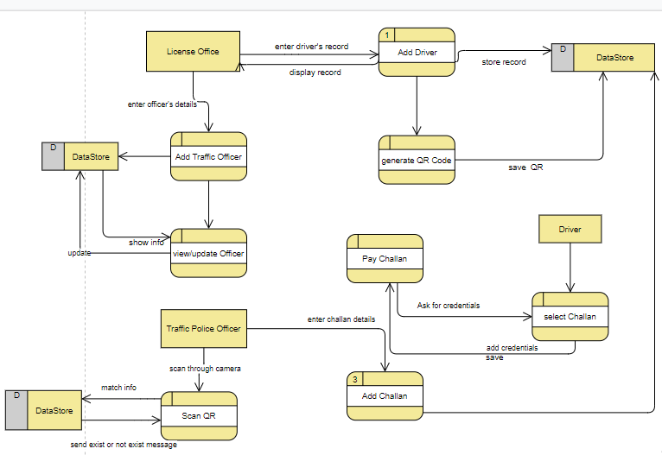

## Diagram 4.5.1 data flow diagram

CHAPTER 5

IMPLIMENTATION

# 5.1 Tools and Techniques

Android studio

Firebase

Python 3.7

## 5.2 Screenshots of Application

These are Screenshots of the Application in the following:

### **5.2.1 Home Page**

This is the home page of our application. This layout will appear when the user will visit.

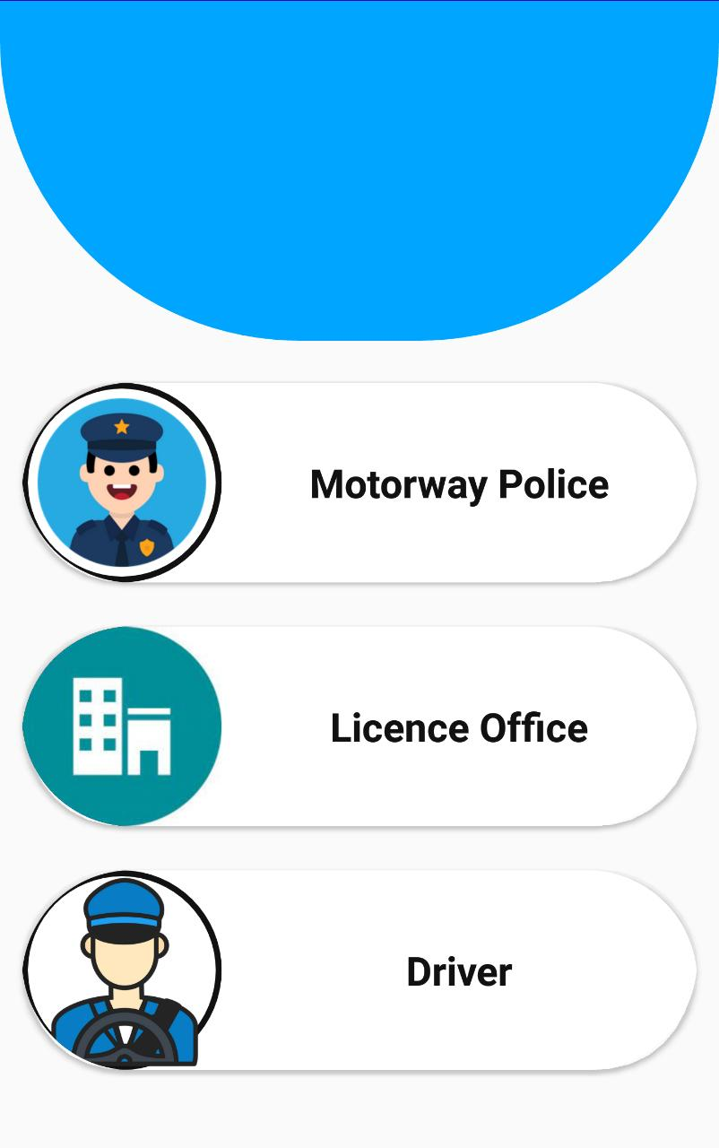

**Figure 5.1 Home page**

### **5.2.2 Login Page**

After home page, login page will display. In the login page user will only have to enter his email address and password. He will remain login until he does not logout. At the end we have provided create an account option so that anyone who has not account can create account directly from here.

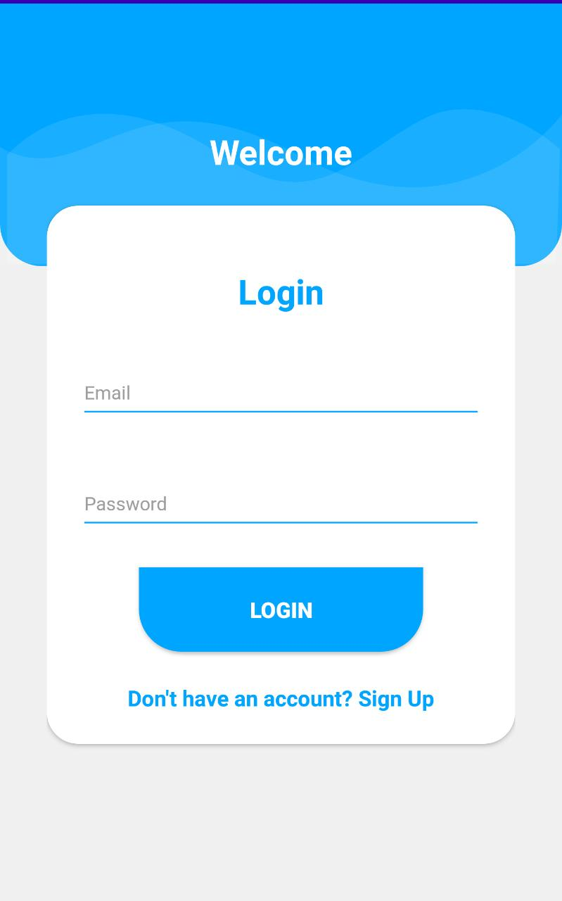

Figure 5.2 User login for Police/License office

### **5.2.3 Add driver and police Record (License Office Dashboard)**

After login page, the registry of police and driver page will appear to the license office. Here now the record of driver and police is registered so that it can easily be detected by monogram and QR code later by police officer.

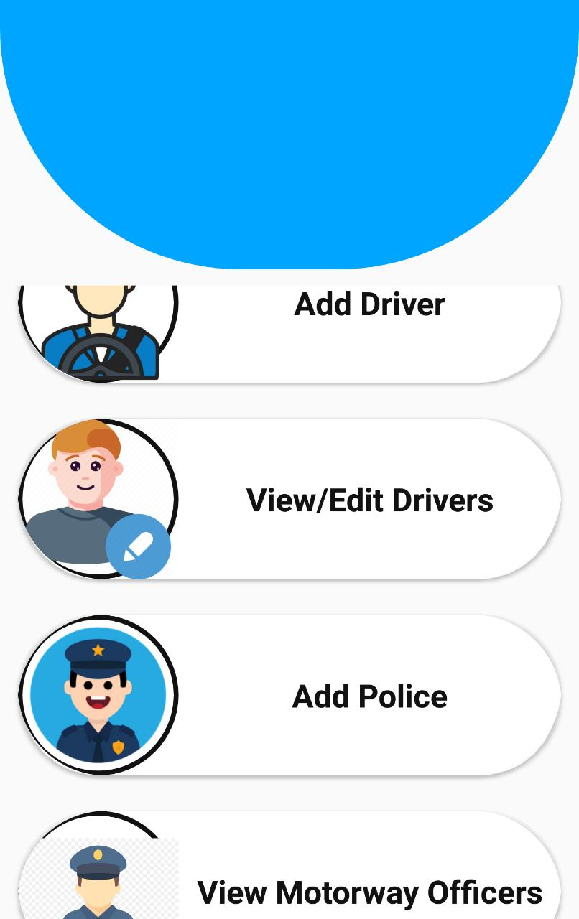

Figure 5.3 Driver/Police Registry

Figure 5.4 Police Registry Figure 5.5 Driver Registry

### **5.2.4 Scan licence QR Code (Police Officer Dashboard)**

After Login to the system Police Officer can scan license QR code to detect fake License.

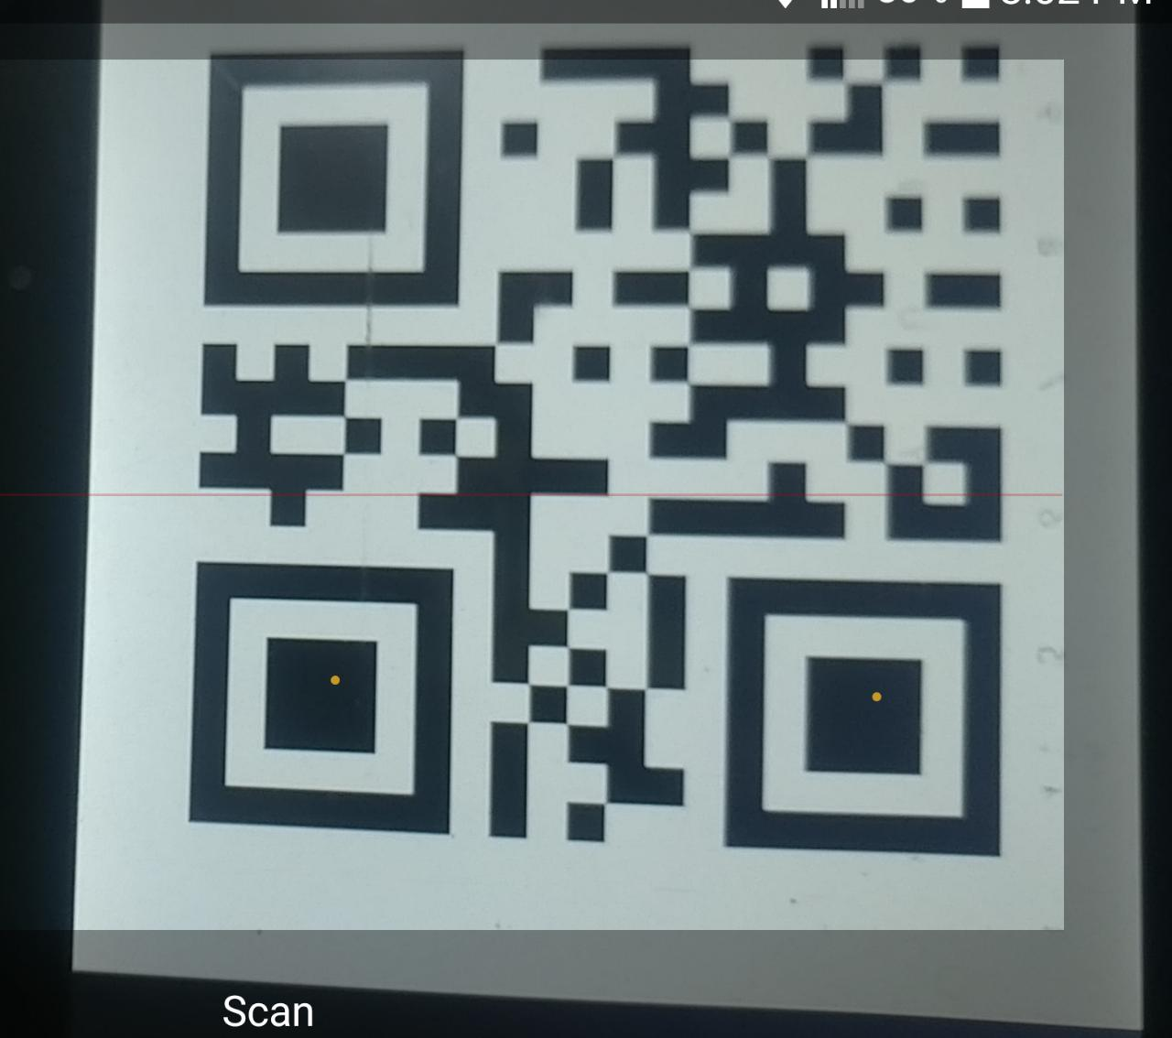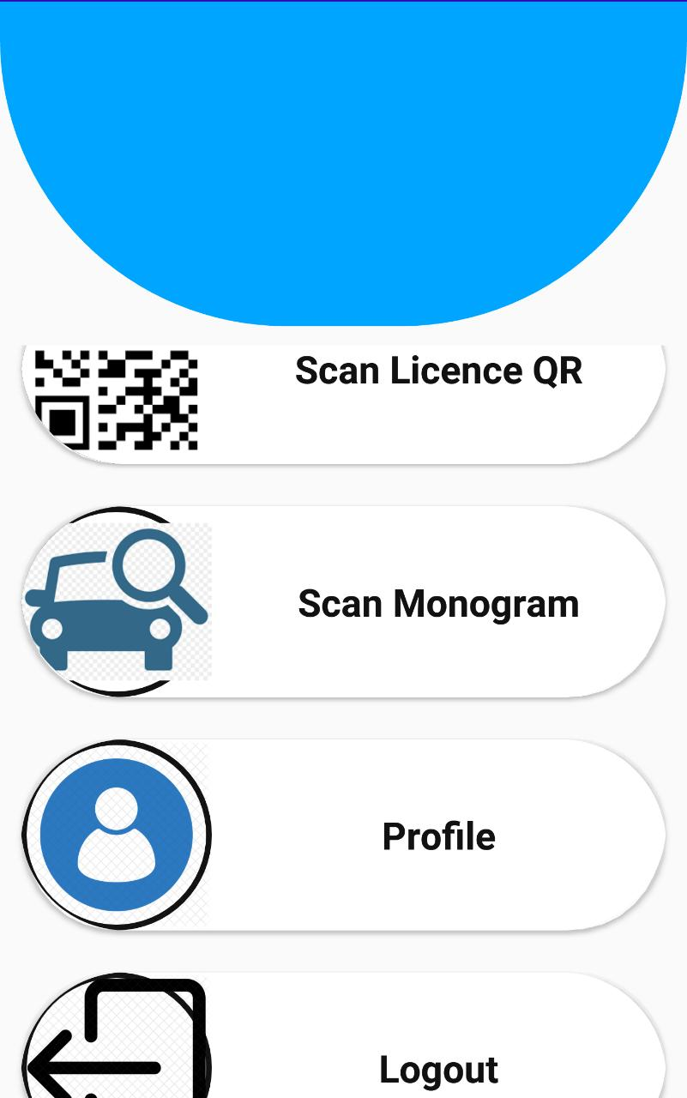

Figure 5.6 dashboard Figure 5.7 Scan QR Code

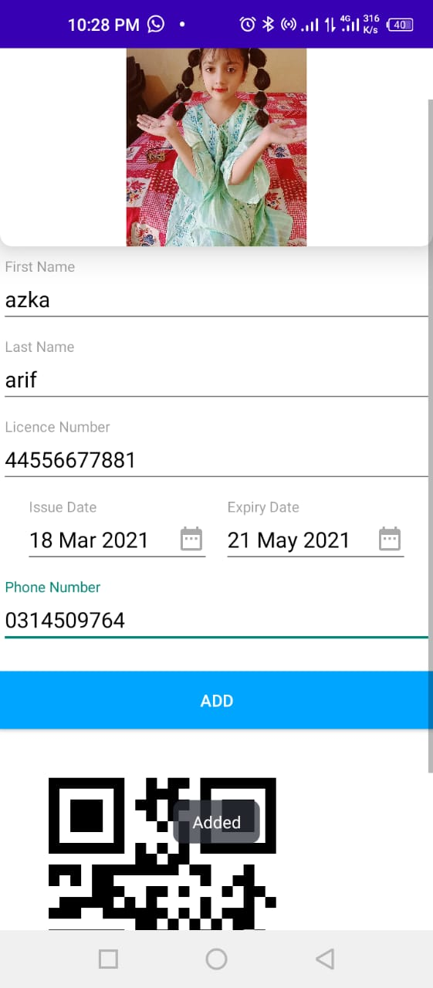 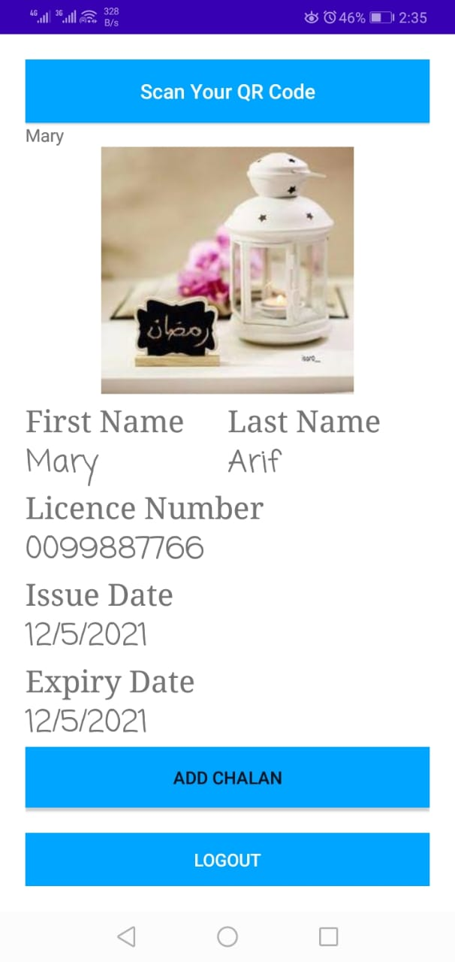

Figure 5.8 adding driver Figure 5.9 Scanning QR

### **5.2.5 Scan Monogram (Police Dashboard)**

Police Officer can also scan vehicle’s Monogram to predict vehicle’s company either it is fake or original.

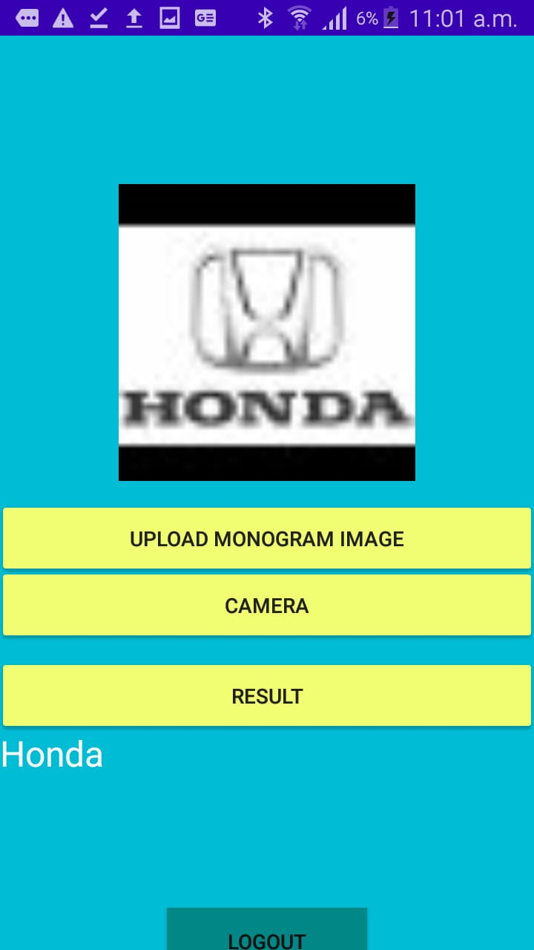

5.10 results after Scanning Monogram

## 

CHAPTER 6

TESTING AND EVALUATION

# Evaluation

Evaluation of system is practice for developing during system testing. Software evaluation involves running software products under known conditions with defined inputs and documented outcomes that can be compared to their expectations.

## 6.1 Testing

Testing is the process of evaluating a system or its component(s) with the intent to find whether it satisfies the specified requirements or not. In simple words, testing is executing a system in order to identify any gaps, errors, or missing requirements in contrary to the actual requirements.

## 6.2 Basic Foundation of testing

## There are two foundations of testing:

### **6.2.1 Black box testing**

Black Box Testing is a software testing method in which the functionalities of software applications are tested without having knowledge of internal code structure, implementation details and internal paths. Black Box Testing mainly focuses on input and output of software applications and it is entirely based on software requirements and specifications. It is also known as Behavioural Testing.

### **6.2.2 White box testing**

White Box Testing is software testing technique in which internal structure, design and coding of software are tested to verify flow of input-output and to improve design, usability, and security. In white box testing, code is visible to testers, so it is also called Clear box testing, Open box testing, Transparent box testing, Code-based testing and Glass box testing.

## 6.3 Types of Testing

### **6.3.1 Unit Testing**

Unit testing is a type of software testing where individual units or components of software are tested. The purpose is to validate that each unit of the software code performs as expected. Unit Testing is done during the development (coding phase) of an application by the developers.

### **6.3.2 Integration Testing**

Integration testing is a level of software testing where individual units / components are combined and tested as a group. The purpose of this level of testing is to expose faults in the interaction between integrated units. Test drivers and test stubs are used to assist in Integration Testing.

### **6.3.3 System Testing**

System testing is a level of testing that validates the complete and fully integrated software product. It is covered under black box testing techniques; the purpose of a system test is to evaluate the end-to-end system specifications. Usually, the software is only one element of a larger computer-based system.

**6.3.4 Function Testing**

Function testing is a type of software testing that validates the software system against the functional requirements/specifications. The purpose of Functional tests is to test each function of the software application, by providing appropriate input, verifying the output against the Functional requirements.

## 6.4 Test Cases

Test cases are created for each of functional requirement. These tests applied on app to test the functionalities

|  |  |  |  |
| --- | --- | --- | --- |
| Test case | Expected results | Actual results | Pass/fail |
| Enter empty field in Email | It should not able user to login to the system | Authentication failed, check your email or password. | Pass |
| Enter wrong email | It should not let the user to login into the system | Authentication failed, check your email or password. | Pass |
| Enter wrong password | It should not able user to login | Authentication failed, check your email or password. | Pass |

#### **6.4.1Test Case for License officer’s Login**

**Test Case:** Login

**Description:** only authorized user must be able to login successfully.

### **6.4.2 Test Case for Traffic Police Officer’s Login**

## Test case: Login

## Description: Only those officers can Login which are registered by License Office.

|  |  |  |  |
| --- | --- | --- | --- |
| Test case | Expected results | Actual results | Pass/fail |
| Enter empty field in Email | It should not able user to login to the system | Authentication failed, check your email or password. | Pass |
| Enter wrong email | It should not let the user to login into the system | Authentication failed, check your email or password. | Pass |
| Enter wrong password | It should not able user to login | Authentication failed, check your email or password. | Pass |

### **6.4.3 Test Case for Driver’s Login**

## Test case: Driver Login

## Description: Authorized driver can get login to the system those who are already registered by License office.

|  |  |  |  |
| --- | --- | --- | --- |
| Test case | Expected results | Actual results | Pass/fail |
| Enter wrong license number | It should not able user to do further tasks | Not letting user to continue | Pass |
| Enter mobile no less than valid digits | It should not let the user to continue | The format of phone number is incorrect, please enter the number in valid format | Pass |
| Enter password in wrong format | User should not receive confirmation code | The format of phone number is incorrect, please enter the number in valid format | Pass |

### **6.4.4 Test case for Police Officer Dashboard:**

## Description: When Police Officer successfully Login to the system He can be able to view his profile, Scan Vehicle’s Monogram, Scan License QR Code, and logout from the system.

|  |  |  |  |
| --- | --- | --- | --- |
| Test case | Expected result | Actual result | Pass/fail |
| Scan wrong License QR | It should not show any result the to the officer | The Scanned QR does not exist | Pass |
| Upload fake or blur Monogram Image | It should not show correct prediction | Does not show result or predict wrong | Pass |
| Scan Monogram by Camera | He may not receive any notification | Get important notifications | Pass |
| View results of Monogram | Results can be shown correctly | Showed correct prediction | Pass |

### **6.4.4 Test Case for License Office Dashboard:**

## Description: After successfully Login into the system with default credentials License Officer can view/ add Drivers, Generate QR code for drivers, view/add Police Officers.

|  |  |  |  |
| --- | --- | --- | --- |
| Test case | Expected result | Actual result | Pass/fail |
| Add Driver’s Info with its all attributes | It should add driver to the system | Driver is added | Pass |
| Add driver without adding driver’s picture | It will not let them add driver | Please upload an image | Pass |
| Add driver with adding any attribute null | It should add driver to the system | Authentication failed | Pass |
| Add Police with password less than 8 characters | It should show error message | Password is too short please enter at least 8 characters | Pass |
| Add police with null email | It will not let them add police | Enter email | Pass |
| Add police with wrong email format | It will not let them add police | Authentication failed: Email format is not correct | Pass |

CHAPTER 7

CONCLUSION

# 7.1 Conclusion

From this system we can conclude that scanning the QR code for obtaining details will be faster than reading from a smart chip. With this system we can also conclude that there is no need of special device for traffic police system like magnetic card readers, only a smart phone is enough for minimizing their hand work. We can update the system by adding new features such as vehicle registration, viewing Challan history and we can design the system as desired with the help of technologies available. Security of the system can be increased.

## 7.2 Future Work

The requirements of users keep on changing as the system is being used so there is always a possibility to add new features.

Some of the future improvements are as follows:

* We can update the system by adding new things such as vehicles verification and registration.
* We can add face recognition for checking drivers.
* We can add a new feature in which drivers can also give reviews and they can also make complains for any misbehaviour of traffic police officer.

### **7.2.1 Future features**

* Face Detection
* Vehicle registration
* Drivers can give Reviews
* Drivers can make complains about officers

## 7.3 References

[1]Ihekweaba Chukwugoziem, Aru Okereke Eze, E. Chiaghana Chukwunonso, International Journal of scientific and engineering research ISJER, A Quick Response (QR) code generator with mobile scan application for mobile network recharge options, 10, ( 2019).

[2] S.R. Bharamagoudar, R.B. Geeta, S.G. Totad, Journal at International journal of advanced research in computer and Communication engineering “Web based student information management system” 2 (2013).

[3] Md. Sanaul Haque, Richard Dybowski, at First International Conference on systems Informatics, Modeling and Simulation “Advanced QR Code based Identity card: A new era for generating student ID card in developing countries” (2014).

[4] SmitaPatil, ShrutiDesurkar,DipaliSanas; “An Intelligent Ticket Checker Application for Train using QR Code”; International Journal of Computer Applications, (2016), pp.15-20.

[5] Y. G. Kim and M. S. Jun, "A design of user authentication system using QR code identifying method," 2011 6th International Conference on Computer Sciences and Convergence Information sTechnology (ICCIT), Seogwipo, pp. 31-35.